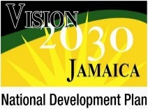

**Vision 2030 Jamaica**

**National Development Plan**

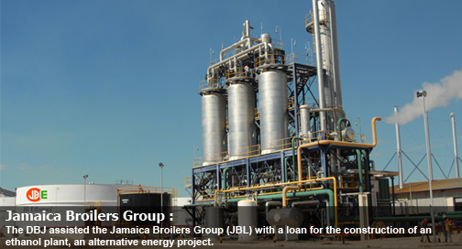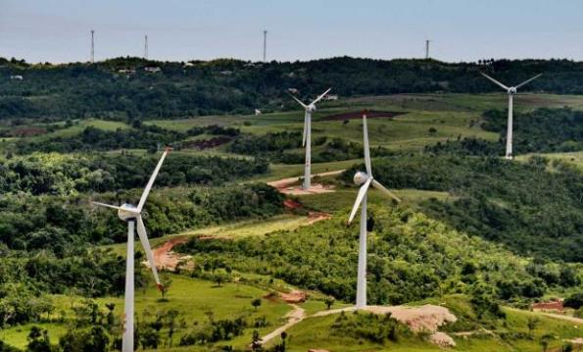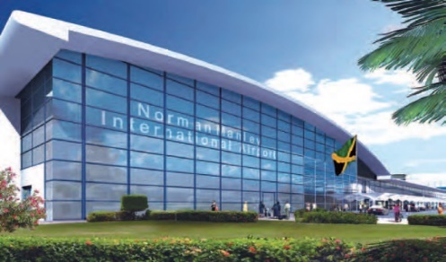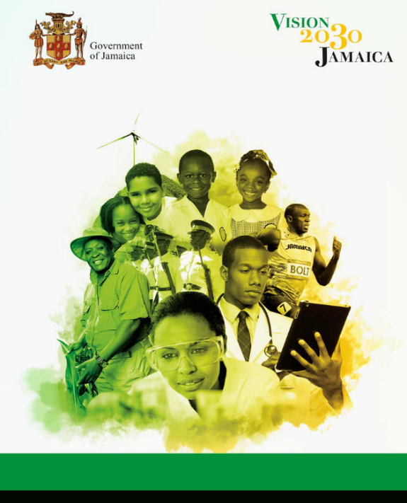

**“Jamaica, the place of choice to live, work, raise families and do business”**

***Excerpts from Draft Medium Term Socio-economic Policy Framework (MTF) 2018-2021***

**Vision 2030 Jamaica – National Development Plan**

Vision 2030 Jamaica – National Development Plan*,* the country’s first long-term strategic development plan, provides a comprehensive planning framework in which the economic, social, environmental and governance aspects of national development are integrated. The Plan, which was approved in Parliament in 2009, is intended to put Jamaica in a position to achieve developed country status by 2030 and is based on the vision statement: *“Jamaica, the place of choice to live, work, raise families and do business”.* This vision statement embodies the clear message that emerged from the inclusive plan development process and encapsulates the yearning of our people for a secure and prosperous future. It calls for every citizen to participate in both the responsibilities and benefits of national development… as a fundamental strategy to advance our nation’s progress.

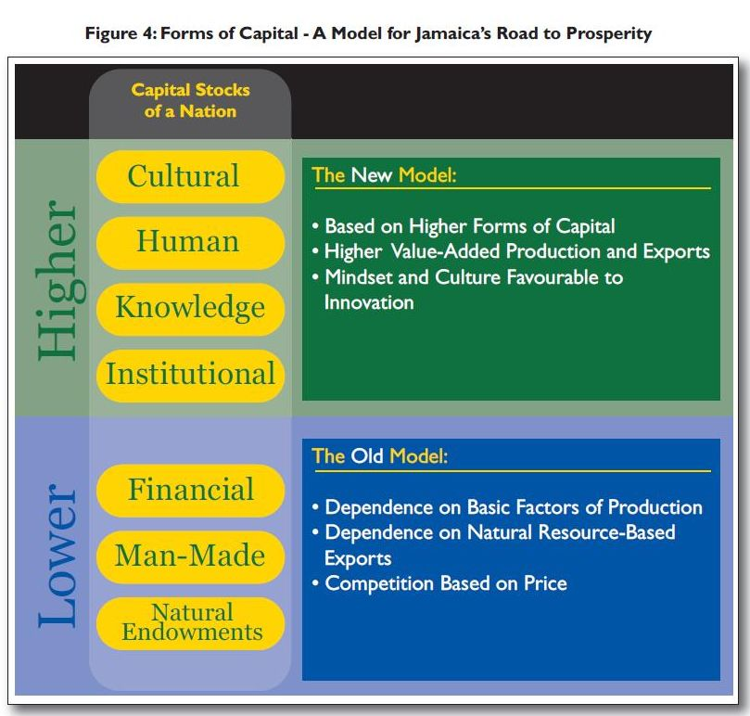Ensuring a secure and prosperous future for all Jamaicans requires a major transformation from a middle income developing country to a country which can afford its citizens a high quality of life and world-class standards in a range of areas – education, health care, nutrition, civility and social order, access to environmental goods and services such as clean air and water among others. Fundamental to this is ensuring that as a country we take the necessary steps to advancing a sustainable society by integrating and balancing the economic, social, environmental and governance components of national development… towards meeting *“the needs of the present generation without compromising the ability of future generations to meet their own needs”*.

Vision 2030 Jamaica therefore introduces a new paradigm, which since its promulgation has continued to redefine the strategic direction for Jamaica – one which puts us on a different path – a path to sustainable prosperity – one that moves us from dependence on the lower forms of capital to developing and sustaining the higher forms of capital – our cultural, human, knowledge and institutional capital stocks to move us into the higher stages of development but also position us to add value to the lower forms of capital… moving us into an innovation-driven stage of development. Whilst exploiting the lower forms of capital, for example, our natural resources for tourism, bauxite, agriculture among others, provides the foundation for development, it is the higher forms of capital that will enable us to create the levels of prosperity required for sustained economic and social development.

Vision 2030 Jamaica is built on a results-based management framework (RBM) and focuses attention on achieving our national goals and outcomes, establishing indicators and targets for monitoring process of our development agenda and allowing us to take corrective action along the way thereby facilitating continuous improvement.

A distinguishing feature of Vision 2030 Jamaica is its focus on implementation and accountability. At the heart of this is an emphasis on prioritization and action. Vision 2030 Jamaica is implemented through a series of Medium Term Socio-Economic Policy Frameworks (MTFs), which identify the priority strategies and actions under each of the country’s 15 national outcomes for each three-year period from 2009 to 2030.

Key attributes of the national development plan:

* It has a long-term planning horizon with a strategic focus
* Enjoys bi-Partisan support
* Is underpinned by high levels of stakeholder involvement and engagement
* Takes into account the views and aspirations of our children and youth
* Is underpinned by a well-defined implementation framework, the Medium-Term Socio-Economic Policy Framework (MTF)
* Has a robust monitoring and evaluation framework comprising indicators and interim targets that allow for the quantitative assessment of progress
* It is underpinned by the principles of sustainability and ensures that all areas of development – economic, social, and environmental are taken into account
* Is easily aligned with key national and international frameworks – the most recent example being Agenda 2030 – Sustainable Development Goals which are expected to be achieved through the implementation of Vision 2030 Jamaica
* Has a strong focus on transparency and accountability by undertaking and making public its performance reports and the country’s development results

**Medium Term Socio-Economic Policy Framework 2018 - 2021**

The Medium Term Socio-Economic Policy Framework (MTF) is the implementation framework of Vision 2003 Jamaica – National Development Plan, and is aligned to the overall vision, goals and national outcomes of Vision 2030 Jamaica – National Development Plan and allows for a stage by stage operationalization of the long-term National Development Plan. It is an implementation framework underpinned by an extensive strategic planning and prioritization process to guide stakeholders to achieve the goals and outcomes of the long-term development plan.

Each MTF therefore serves as a companion document to the Vision 2030 Jamaica – National Development Plan, comprising the medium term priority strategies and actions that will be pursued in the implementation of the Plan. The MTF is aligned with the country’s long-term vision, goals and national outcomes as contained in the NDP and allows for implementation that incorporates continuous improvement.

MTF 2018 – 2021 is the 4th medium term strategic programme to advance the implementation of the Vision 2030 Jamaica – National Development Plan. MTF 2018 - 2021 is based on the nation’s development aspirations and guiding principles as articulated in the country’s long-term development plan and is aligned to Agenda 2030 Sustainable Development Goals (SDGs) MTF 2018 - 2021 will consolidate the gains made in the previous MTFs for 2009-2012, 2012-2015 and 2015 - 2018 and strengthen the foundations for achieving the country’s long-term results, taking into account the many opportunities that surround us, the current developmental challenges we are confronted with and the global context.

The preparation process for the MTF was led by the Vision 2030 Jamaica Secretariat at the Planning Institute of Jamaica (PIOJ) which ensured high levels of stakeholder consultation and input and the participation of over 600 key stakeholders from the public and private sectors, civil society organizations, international development partners and youth and children. MTF 2018 – 2021 process recognizes and took into account other planning documents and frameworks such as: Cabinet Priorities, the Economic Growth Council’s *“Call to Action”*, Whole of Government Business Plan, the corporate and operational plans of government ministries, departments and agencies (MDAs); Agenda 2030 Sustainable Development Goals and the associated targets under each goal as well as the defined SDG accelerators contained in “Jamaica’s Road Map for the Implementation of the SDGs”, among others.

MTF 2018 – 2021 therefore presents the medium-term development priorities, strategies and actions to be pursued under each of the 15 National Outcomes under Vision 2030 Jamaica, including the nine (9) goods- and services-producing industries under National Outcome #12 (Internationally Competitive Industry Structures). It sets out the timeframe for implementation of the priority strategies and actions for each of the 15 National Outcomes, as well as the main agencies and stakeholders responsible for implementation of each priority strategy and action. In addition, it presents the key national indicators and targets that will provide a quantitative framework for measuring the progress toward achievement of MTF 2018 - 2021 and the long-term goals and outcomes of Vision 2030 Jamaica.

Today, Jamaica continues to face many challenges – ranging from economic, social and national security challenges, pressures on its natural environment, and the increasing impacts of global climate change. Notwithstanding, there continues to be consensus by stakeholders on the need to undertake fundamental reforms to consolidate our macroeconomic gains over the years, improve our international competitiveness, undertake holistic development in our most volatile and at-risk communities, protect the most vulnerable groups in our society, and strengthen the resilience of our built and natural environments. MTF 2018 - 2021 presents the priority strategies and actions over the medium term and serves as a framework for all Jamaicans – those in the public and private sectors and in civil society, along with our institutions and our development partners to work towards the achievement of the our country’s agreed development goals within this common development framework,

**ensuring a secure and prosperous future for our people… and making “Jamaica, the place of choice, to live, work, raise families and do business”**

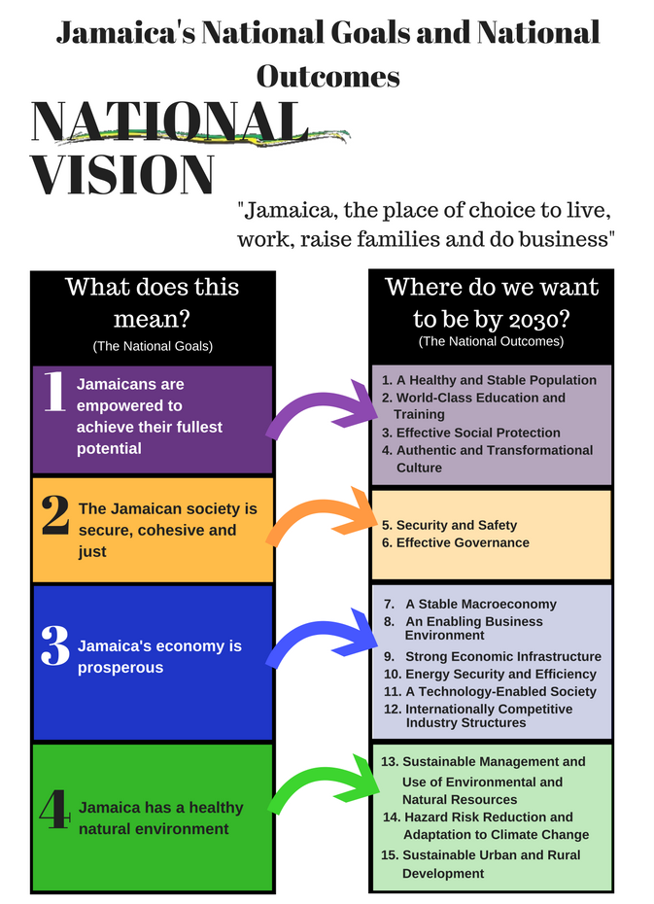**The Jamaica We Want by 2030**

The Jamaica we want by 2030 is one in which each Jamaican can secure sustained and broad-based improvement in his/her quality of life and one in which our country can transform into “the place of choice to live, work, raise families and do business”. In other words what we want is sustainable prosperity and inclusive growth, equity and good governance.

To achieve this, Vision 2030 Jamaica - National Development Plan articulates a comprehensive and integrated strategy around four 4 national goals and 15 national outcomes as presented in Figure 1. These National Goals are mutually reinforcing and synergistic in design, and their achievement cannot be realized in isolation from each other. These goals and their associated national outcomes, along with national strategies, programmes, projects and activities collectively represent a development planning approach that is broad in scope, participatory in design and implementation, long-term in reach and transformational in character. Vision 2030 Jamaica therefore provides a comprehensive framework in which the linkages among economic, social, environmental and governance spheres of development are made, and presents a broad strategic thrust for the transformation of the Jamaican economy and society towards sustainable development and prosperity for the Jamaican people.

By focusing on sustainable development, the Plan ensures that the three dimensions of sustainability are fully integrated within a Results-Based Management (RBM) Framework. The four goals and 15 national outcomes of Vision 2030 Jamaica cover these three dimensions: goals 1 and 2 are social goals; goal 3 is an economic goal; and goal 4 is an environmental goal. Additionally, the design and plan implementation frameworks of Vison 2030 Jamaica comprise key prerequisites for the realization of development practice that integrates the three dimensions of sustainability. These include:

* The long term horizon of the plan which covers a 21-year implementation period;
* A people-centred approach to development, which directs guiding principles that encompass the three dimensions of sustainable development and good governance, including partnership and transparency and accountability;
* An outcomes based medium term planning framework, which centres on the achievement of outcomes through a multi-dimensional strategic framework that requires intersectoral and cross sectoral collaborations;
* A monitoring and evaluation framework - characterized by national outcome/impact indicators aligned with the goals and outcomes; and representative of the 3 dimensions of sustainability.

**The Alignment of Vision 2030 Jamaica with the Sustainable Development Goals**

Vision 2030 Jamaica serves as the axis around which efforts to achieve the Sustainable Development Goals will be organized. The SDGs were adopted by the 193 Member States of the United Nations in September 2015 and came into force on January 1, 2016. This landmark agreement envisions the creation of a better world that is free of poverty and underpinned by universal peace and where ‘no one is left behind’. The SDGs is therefore an agenda to advance - People, Planet, Prosperity, Peace and Partnership (5Ps). This is not dissimilar to the overarching vision of Jamaica and the goals and outcomes contained in the National Development Plan. In fact, Vision 2030 Jamaica served as the framework for the development of the country’s National Outcome Document for the SDGs.

Vision 2030 Jamaica’s position regarding the implementation of Agenda 2030 was cemented in the *Road Map for SDG Implementation in Jamaica[1],* which identifies Vision 2030 Jamaica and specifically the Medium Term Socio-Economic Policy Framework (MTF) as the vehicle for implementation of the Agenda. The Road Map states a 91 per cent alignment between Jamaica’s national development agenda[2] and the SDGs; and presents a broad framework for strengthening the Plan Implementation process towards accelerated concurrent achievement of Jamaica’s national development goals and outcomes, and the SDGs. The areas covered to accelerate the achievement of the goals include: an action framework; financing; data monitoring and reporting; coordination – institutional mechanisms; and advocacy. The recommendations have been incorporated in MTF 2018-2021 with the accelerators aligned to prioritized strategic actions being pursued to advance the achievement of the 4 Goals and 15 National Outcomes of Vision 2030 Jamaica.

Under Medium Term Socio-Economic Policy Framework (MTF) 2018-2021, Jamaica will advance the mainstreaming of the 2030 Agenda and its 17 SDGs within the implementation of Vision 2030 Jamaica. MTF 2018-2021 shows the following alignments:

* The alignment of the National Outcomes (of the 4 National Goals) of Vision 2030 Jamaica and the SDGs
* The alignment of the priority sector strategies to advance each National Outcome with relevant SDG targets (see table of priorities for each outcome)
* A general alignment of relevant SDG indicators with the priorities being pursued to advance the achievement of each national outcome

Key priorities for the period 2018 - 2021 to advance the mainstreaming of Agenda 2030 in Vision 2030 Jamaica Plan Implementation and build Jamaica’s capacity for monitoring and reporting on the SDGs include:

* Strengthening the coordination mechanisms for mainstreaming, and monitoring and reporting on the SDGs
* Building national capacity for aligning the SDGs and respective targets with national and local level development processes – beyond planning to action
* Building national data and statistical capacity, which will support the monitoring of the SDGs Global Indicators
* Building national capacity for achieving policy coherence in advancing integrated sustainable and inclusive development
* Preparing reports on Jamaica’s progress in implementing and monitoring the SDGs

**Financing Vision 2030 Jamaica – Financing Our Country’s Development**

It is well recognized globally that financing for development is a complex task and would require coordination among public and private sectors, public sector and the international development partner community and also coordination with civil society organizations. Coupled with coordination would be the need for meaningful commitment of all stakeholders. Resources for the implementation of MTF 2018 - 2021 will come from a range of sources, including the GOJ budget (Capital A and B), private sector investments, civil society organizations, IDPs and the Diaspora. Investments are required, both in the private sector to sustain and increase economic activity, and in the public sector to provide the enabling environment, framework and impetus for growth and development. Some of the key assumptions underlying support for MTF 2015-2018 are that:

* Improvements in economic growth will occur
* Domestic revenue collection will improve
* Monitoring and evaluation will be strengthened to ensure effective use of public resources
* Public-private partnerships will be enhanced, facilitating implementation of priorities
* There will be further improvement in the business environment
* There will be ongoing support from the international development community towards the implementation of specific projects and programmes that will yield high economic and social returns
* Lower energy (oil) prices have the potential to reduce balance of trade deficits and therefore increase fiscal resources for other purposes

As was the case with the 3 previous MTFs, emphasis will be placed on ensuring that planning, budgeting and resource allocation mechanisms are successfully aligned and integrated for the implementation of MTF 2018 – 2021 priorities. The Ministry of Finance and the Public Service plays a pre-eminent direct role in resource allocation within the public sector, primarily through the fiscal budget, as well as an indirect role in broader resource allocation across sectors through the impact of its policies relating to taxation, incentives and other macroeconomic instruments. The MFPS also is expected to play a role in ensuring that resources are used effectively by being a central part of the monitoring process and by enforcing accountability.

In order to ensure effective resource allocation within the public sector for the implementation of MTF 2018 - 2021, the following steps will be taken:

* Ongoing alignment of the three-year corporate/strategic business plans and one-year operational Plans of MDAs with the strategies and actions of the MTF
* Ensuring consistency of the fiscal budget with the three-year corporate/strategic business plans and one-year operational plans of MDAs
* Ensuring that effective resource allocation mechanisms are developed, strengthened and utilized

**The Relevance of Vision 2030 Jamaica for the Future**

The following key elements support the importance of Vision 2030 Jamaica – National Development Plan to 2030.

* The Plan continues to endure a national development planning framework underpinned by strong consensus of a wide range of stakeholders
* It has been benchmarked to regional and global best practices and is considered as a best practice in development planning in Latin America and the Caribbean
* It supports deepening integration with results-based planning, budgeting and monitoring and evaluation (M&E) processes in GoJ
* It is accepted and used by IDPs as basis for preparation of country strategy programmes for Jamaica
* It is effectively alignment with Agenda 2030 Sustainable Development Goals (SDGs)
* Addresses long-term sustainable development challenges including climate change
* It is built on and supports a highly participatory planning processes open to all stakeholders
* It is open to innovation and built on continuous improvement with the MTF playing a key role in facilitating continuous improvement and allowing for changes to be made along the way

1. Approved by Cabinet in June 2017
2. The major policy, strategic and planning documents were examined, including Vision 2030 Jamaica – National Development Plan to which the other documents are aligned.